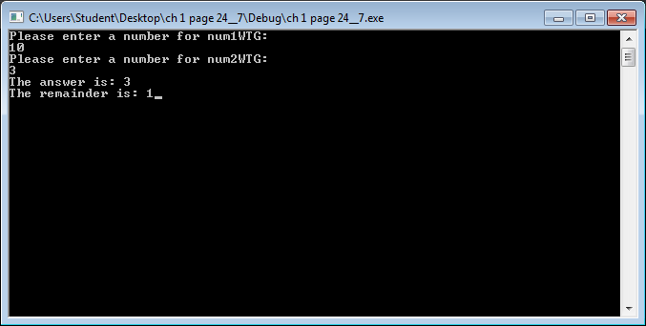

#include <iostream>

#include <math.h>

using namespace std;

int main()

{

int num1WTG;

int num2WTG;

int answerWTG;

cout << "Please enter a number for num1WTG: \n";

cin >> num1WTG;

cout << "Please enter a number for num2WTG: \n";

cin >> num2WTG;

answerWTG = num1WTG / num2WTG;

cout << "The answer is: " << answerWTG;

answerWTG = num1WTG % num2WTG;

cout << "\nThe remainder is: " << answerWTG;

return 0;

}